Digital sensor specifications:

I2C Ambient Light sensor

Specification | Detail
Input Voltage | 3V3
Operating Temperature | -10°C to 70°C
Power Consumption | ≤ 1mW
Output resolution | 16 bit
I2C Slave address bit depth | 7 bit
I2C mode | Fast mode (up to 400 kBits/s)
Light input range | 0.01 lux to 64000 lux
Minimum pull-up resistor value | 1 kΩ
Maximum pull-up resistor value | 10 kΩ
Recommended pull-up resistor value | 8.2 kΩ

The sensor module must take 3V3 power from the main 3V3 rail. It must take a clock input from the microcontroller and output serial data using I2C. It must connect to a level interrupt pin on the microcontroller. It must measure ambient light and output the light level in 16 bit resolution over the I2C connection. The I2C connection must use 7 bit slave addresses and operate in fast mode

Analogue sensor 1 specifications:

Potentiometer
Note: Justin Pead has told us that using a potentiometer as an analogue sensor is acceptable. Nevertheless we have also added a 2nd analogue sensor (see below), which we believe we can still do within the specified budget.

Specification | Detail
Input Voltage | 3V3
Operating Temperature | -10°C to 70°C
Power Consumption | ≤ 1mW
Resistance | ≥ 10 kΩ
Resistance tolerance | ≤ ± 20%
Operating life | ≥ 5000 cycles
Rotation Torque | ≤ 10 mN.m
Maximum rotation angle | ≥ 270°
Mounting type | Vertical

The sensor module must take in 3V3 power from the main 3V3 rail. It must output an analogue voltage based on the degree to which the potentiometer has been turned. It must draw less than 1 mW of power. It must be able to survive up to 5000 cycles.

Analogue sensor 2 specifications:

NTC thermister

Specification | Detail
Input Voltage | 3V3
Power consumption | ≤ 1 mW
Resistance at 25°C | ≥ 10 kΩ
Resistance tolerance | ≤ ± 1%
Measurement temperatures | ≤ -10°C to ≥ 70°C
Nominal B-constant | ≥ 4000
Voltage divider voltage at 25°C | 0.5 x 3V3

The sensor module must take 3V3 power from the main 3V3 rail. The sensor will be placed in series with a 100 kΩ resistor to form a voltage divider. The sensor must be able to read temperatures between -10°C and 70°C.

Draft schematic and BOM:

Schematic:

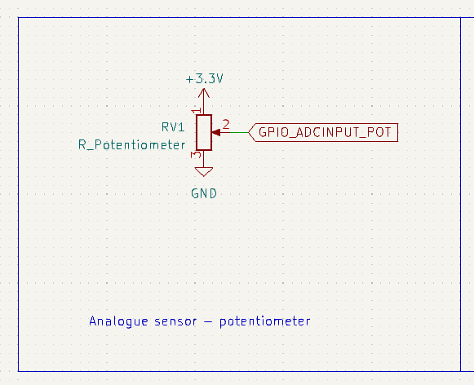
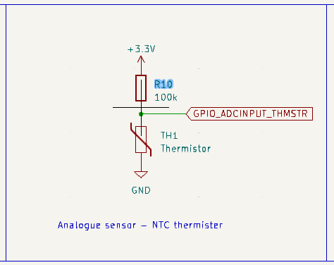
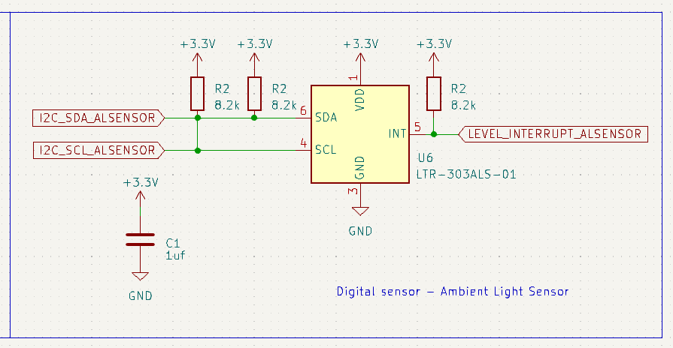
BOM:

<insert link here>
See sheet 3 (sensors)

Digital sensor interface:

Ambient light sensor

Electrical (pinout):

Pin | Description | Connections
1 | Supply voltage | 3V3  Capacitor +
2 | No connection | NC
3 | Ground | GND  Capacitor -
4 | I2C serial clock (SCL) | SCL pin on microcontroller I2C bus  Pull-up resistor to 3V3
5 | Level interrupt | INT pin on microcontroller  Pull-up resistor to 3V3
6 | I2C serial data (SDA) | SDA pin on microcontroller I2C bus  Pull-up resistor to 3V3

The module will send digital data to the microcontroller via an I2C bus on the microcontroller. All pins will have 0Ω resistors in series with the “main” pin connections so that the sensor can be disconnected in the event that it doesn’t work properly.
All pins will have 0Ω resistors in series with the “main” pin connections so that the sensor can be disconnected in the event that it doesn’t work properly.

Electromagnetic (light):

The module will receive ambient light, which the sensor will internally convert to a digital signal (to be sent out of the module as an electrical signal over I2C)

Sensor dimensions:

Width: 2 mm
Length: 2 mm
Height: 0.7 mm

Analogue sensor 1 interface:

Potentiometer

Electrical (pinout):

Pin | Description | Connection
1 | Supply voltage | 3V3
2 | Output | GPIO pin, configured for ADC input
3 | Ground | GND

The module will send an analogue voltage to a GPIO pin configured for ADC input on the microcontroller.
All pins will have 0Ω resistors in series with the “main” pin connections so that the sensor can be disconnected in the event that it doesn’t work properly.

Tactile input:

The twist-knob of the potentiometer can be turned by hand to change the output voltage. This can be used during the configuration stage to fine tune the settings of the device. Additionally it could be used to sense “human data”, where the readings in the device

Mechanical input:

The twist knob of the potentiometer could also be connected to a small mechanical system that turns the knob. For example, the mechanical input could come from a small wind vane, or from a window where the researcher wants to measure when the window is opened and how wide it is opened.

Sensor dimensions:

Width: 9.8 mm
Length: 12 mm
Height: 15 mm
Knob diameter: 6 mm

Analogue sensor 2 interface:

NTC thermister

Electrical (pinout):

Pin | Description | Connection
1 | Connection to 100 kΩ resistor of voltage divider and ADC input | GPIO pin, configured for ADC input  100 kΩ resister pulled up to 3V3
2 | Ground | GND

The sensor module will send an analogue voltage to a GPIO pin configured for ADC input on the microcontroller.
All pins will have 0Ω resistors in series with the “main” pin connections so that the sensor can be disconnected in the event that it doesn’t work properly.

Temperature input:

The thermister reacts to changes in temperature. It is a negative temperature coefficient thermister, which means that its resistance decreases as the temperature increases. This resistance change will be read by placing the thermister in series with a static 100 kΩ resistor to form a voltage divider.
The thermister’s change in resistance with temperature is non-linear. This will be compensated for in software of the microcontroller so that accurate temperature readings can be obtained.

Sensor dimensions:

Width: 0,5 mm
Length: 1 mm

